Creative Learning Officer
Recruitment Pack
April 2024

Team: | Learning & Engagement
Location: | Chichester Cathedral
Contract Type: | Permanent
Hours: | Full Time
Salary: | £37,000

Any questions?
Head of HR, Val Timlin
val.timlin@chichestercathedral.org.uk

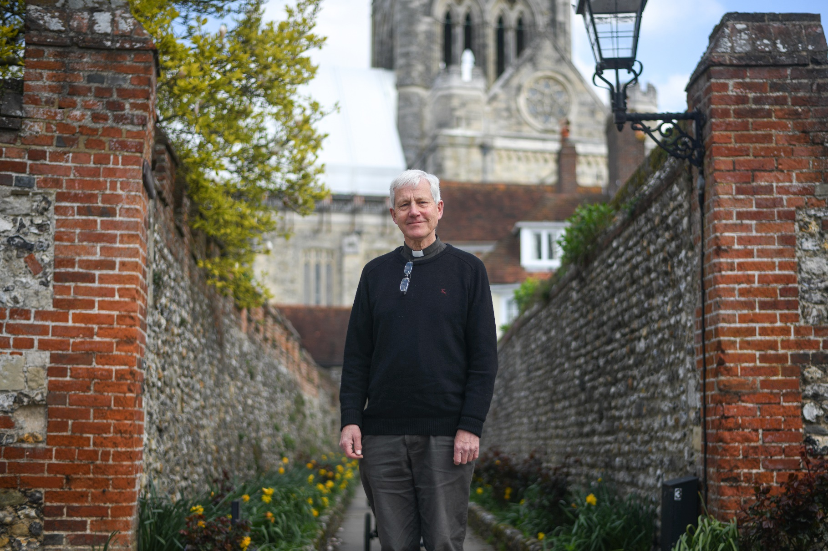

Welcome from the
Interim Dean of Chichester

Dear candidate
Thank you for your interest in this post.
Chichester Cathedral values Christian education for all ages, and now wishes to expand its work with families and young people. This post offers scope for nurturing the faith of children and young people in collaboration with Cathedral colleagues and with a range of other partners, including the Diocese, local schools and churches.
We are looking for candidates who are creative, self-motivated, imaginative, and enthusiastic about sharing the Gospel. In return, we are offering the chance to work as part of a unique community of faith, centred around a building of immense spiritual power.
The Cathedral is at a time of change and opportunity, awaiting the arrival of a new Dean and preparing to celebrate our 950th anniversary in 2025. We are at the heart of a beautiful city, close to the Downs and the sea, with its own university and college and a wide mix of schools. Our population includes many children and young people, and an increasing number of them attend our 9.15 Eucharist each Sunday.
There is huge potential to develop Christian education here in Chichester, and we wish to do all that we can to fulfil it. If you are excited by our vision and feel that you could use your gifts and experience to help us, we would love to hear from you.
Please be assured that you are in our prayers.

The Reverend Canon Simon Holland
Interim Dean of Chichester
About Chichester Cathedral

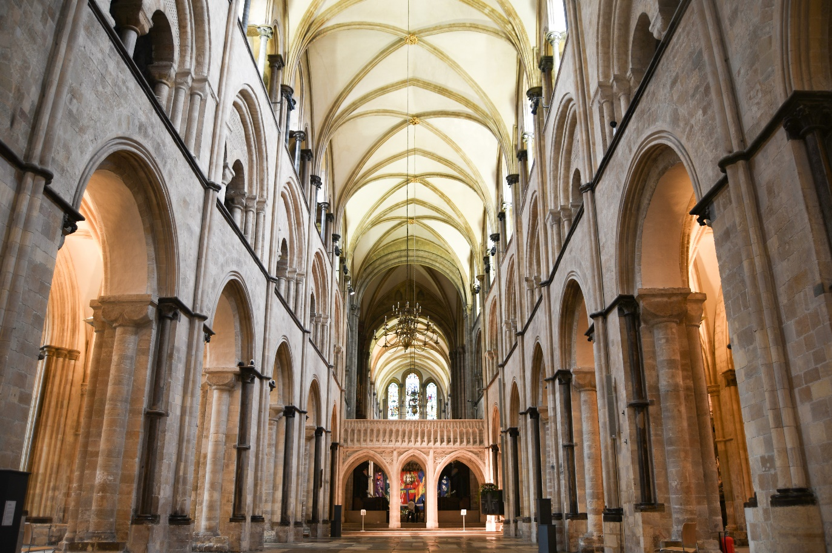
The Cathedral is a living church that has been at the centre of life in Chichester for over nine centuries. We are a place of worship and mission, the Mother Church of the Diocese of Chichester (which covers East and West Sussex) and the seat of the Bishop of Chichester. We are supported by a committed worshipping congregation, a small but dedicated staff team and over 400 volunteers.  The Cathedral is a leading visitor attraction, a venue for artistic and cultural activity, and an all-round hub for the community, welcoming over 250,000 visitors each year. Music is a central element in the Cathedral’s life. The Choir, which offers eight sung services each week and contributes to the Cathedral’s outreach around the diocese, has a high reputation at national and international level. We also host many high-quality musical performances each year by choirs, orchestras and chamber groups. | The Cathedral presents a comprehensive events programme and has a trading subsidiary, Chichester Cathedral Enterprises Ltd (CCEL), offering hospitality and retail services that support the Cathedral in delivering its mission. We have both a residential and commercial property portfolio many of them listed, in the Cathedral Close and beyond.  The Cathedral does not receive statutory or Church of England funding and is self-supporting, relying on self-generated income, donations, and fundraising activities. The Chapter is supported by the Chichester Cathedral Restoration & Development Trust and the Friends of Chichester Cathedral.  Further information about Chichester Cathedral can be found on the Cathedral website, including our Annual Report & Accounts.

Our Vision
The Cathedral’s anniversary in 2025 invited us to think more deeply about our purpose here in Chichester – in our worship, in our teaching, in our common life, in our commitment to diversity and inclusion and in our mission.
Invoking the prayers of St Richard, we have been drawn to that vein of spiritual renewal that animated the Latin West and especially this diocese in the thirteenth century – that is, the spirituality of St Dominic, which formed Richard and which shaped his own ministry here in Sussex, not least in resourcing his own pastoral care, teaching ministry, and expansion of the Cathedral’s life.
We’ve therefore taken inspiration from Dominican life in the so-called ‘Four Pillars’: Prayer, Study, Community and Mission. In these we begin to see a pattern of common life that helps us to fix our eyes on Christ as a means to becoming more prayerful; wiser in our understanding of what it means to be Christlike in the 2020s; becoming a community that is compassionate and joyful; and becoming more courageous in our mission and service to the world.
We hope you find inspiration and challenge in this pattern of life that we are setting before the Cathedral community and ask for your prayers as we seek to build up the household of faith here.

Prayer  Committing ourselves to seeking the face of God afresh in contemplation and worship, we hope to be guided by The Spirit to enter more deeply into the mystery of Jesus Christ and to radiate His beauty. | Study  Rooted in prayer, we seek to discern what it means to be human in an age of technological, political, social and economic change – through study, teaching and engagement with the World.
Community  Shaped by the insights of prayer, contemplation and study, we seek to build up our community in love, compassion and hospitality – encouraging each other to step out in faith and hope. | Mission  As a discerning, prayerful and loving community, we seek to take the message of God’s grace into the World with imagination, beauty and confidence, radiant with the promise of salvation.

You can read our full Vision document on the Cathedral website.

Commitment to Safeguarding
In accordance with Church of England’s policy, Promoting a Safer Church and the House of Bishops’ Safeguarding Policy and Practice Guidance, Chichester Cathedral is committed to the safeguarding of children, young people, and vulnerable adults who may be at risk.
The Cathedral works in partnership with the Diocese of Chichester to ensure that we operate in accordance with best practice at all times.
The care and protection of children, young people and vulnerable adults are the responsibility of the whole Cathedral community, whether clergy, staff, volunteers, contractors or members of the congregations. Everyone who participates in the life of the Cathedral has a role to play in promoting a safe environment for all.
To learn more about Safeguarding at the Cathedral please see our website.

Commitment to Equality & Diversity
At Chichester Cathedral we are dedicated to encouraging a supportive and inclusive workplace culture amongst our employee and volunteer workforce. It is our aim to ensure that if you work here or apply to work here, on either a paid or voluntary basis you will have an equal opportunity. We are also committed to working towards an organisation workforce that is diverse and as representative of our wider community as it can be.
We respect and value each of our employees and volunteers and are committed to enabling you to be able to perform to the best of your abilities and to be your authentic self in the workplace.

About the Role
Come and be a part of 950 years of learning

Chichester Cathedral is one of the most significant spiritual, educational, artistic and heritage destinations in the South East. A place of Christian worship and learning for nearly 950 years, we continue to remain open for everyone, welcoming approximately 250 000 visitors from all over the world each year.

This is an exciting time to be joining the Cathedral as we prepare to celebrate our 950th anniversary in 2025 and as we establish our new Learning and Engagement Team.

The Cathedral was built for the glory of God to tell a story through worship, teaching, the arts and architecture. That story needs to be delivered with impact. Schools are looking for experiences that cannot be provided in the classroom and memorable ways to reach a wide range of children and young people.

The learning programme we seek to offer will be a distinctive reflection of the Cathedral’s Christian mission, offering something different from other learning providers. It will draw on the Cathedral’s Vision with opportunities for quiet reflection, collective acts as well as individual development. With a focus on RE, History and Art, it seeks to pose and respond to the bigger questions of life.

Chichester Cathedral is a creative space which demands a creative response. Emphasis will also be on interactivity, experiential learning, exploration, discovery, with children and young people leading their own learning as active, not passive participants.

Working with talented volunteers, this role is a key part of the Cathedral’s Vision to engage children and young people more fully. The engagement of families is important to us in providing opportunities for learning together and building long-lasting connections. In holidays and at other occasions, we desire to help families explore our sacred space and also share in partnerships across the city.

We are seeking a creative and inspirational leader who can bring the Cathedral and its Christian story alive to children and young people of all ages with a fresh and exciting perspective. Cathedrals are places of conversation, of sanctuary and of transformation. We are excited about the gifts our new Learning Officer will bring to this important role.

If you would like an informal conversation with the Canon Chancellor, Jack Dunn, who has particular responsibility for our ministry to children, young people and families, please email: HR@chichestercathedral.org.uk

JOB DESCRIPTION

Job Title: | Creative Learning Officer
Team: | Children and Young People
Location: | Royal Chantry Offices
Line Manager: | Chancellor
Contract type: | Permanent
Hours: | 1.0 FTE
Date of completion: | March 2024

1 | Job Purpose
To provide a creative learning programme of opportunities for schools and families which uses the Cathedral as a resource to devise a range of experiential and interactive sessions. The main focus will be Religious Education and Spirituality, but also supporting History, Art and Citizenship curriculum.

To work with the Operational Safeguarding Lead to ensure that the Cathedral complies with its safeguarding responsibilities and commitments.

2 | Principal Accountabilities
With schools
- to work with teachers, children and young people to understand their learning needs and to develop appropriate curriculum-based activity to meet these needs.
- to develop content and creative ideas for engagement which includes commissioning creative practitioners, digital and other freelance providers;
- to deliver a creative, blended learning programme, including opportunities for regular outreach visits to schools, hosting schools at the Cathedral and digital learning, which:
- encourages pupils and students to engage with “big questions” of life,
- ethics and meaning and develops critical thinking
- enables children and young people to reflect and ponder
- supports the spiritual, moral, social and cultural development of
- pupils and students and provides guidance for teachers
- to maintain up-to-date knowledge of best practice in schools, the National Curriculum [particularly syllabuses and resources for RE including exam specifications for GCSE and A Levels], and current educational requirements, for example around inspections;
- to support schools in planning visits and to follow the appropriate Cathedral policies with reference to safeguarding, risk assessment and health and safety procedures.
- to build positive relationships and develop contact with schools, for example through a regular electronic newsletter;

With the wider community
- to provide a regular programme of family holiday activities/events which welcome in children and families (particularly those from areas of higher deprivation) and encourage deeper engagement;
- to programme activities for families, children and young people to complement wider themes agreed across the Cathedral, for example our environmental ambitions, and/or existing events and exhibitions being held at the Cathedral;
- to offer a range of age and educational level appropriate teaching opportunities across the year at the Cathedral, including conferences, teaching weeks and holiday teaching session.

With colleagues
- to lead the recruitment, training and management of learning volunteers in line with Cathedral policies and procedures;
- to support effective Safeguarding across the entire life of the Cathedral;
- to develop and maintain good relationships with colleagues in the Diocesan Board of Education and other local educational contexts to seek opportunities for partnership working;
- to support the ministry and mission of the wider Cathedral team in engaging with Children, Young People, Families and Caregivers as a priority across the whole life of the Cathedral and, in particular, to support the Children and Youth Ministry Lead with this vital ministry;
- to support colleagues in teams across the cathedral to comply with their Safeguarding responsibilities and commitments.

3 | Level of Responsibility
a | People  Responsible for leading and co-ordinating the learning volunteers.
b | Financial Management  Responsible for planning appropriate spend and managing a resource budget.
c | Other  Member of the Cathedral Programming Group and the Safeguarding Management Committee
4 | Contacts
Canon with oversight for Children, Young People, Families and Caregivers
Canon with responsibility for Learning
Children and Youth Ministry Lead
Visitor Experience Team
Diocesan staff, especially the Board of Education
Local education providers and organisations e.g. The Novium, Pallant House Gallery etc
Operational Safeguarding Lead to ensure effective safeguarding across the Cathedral.

5 | Special Requirements
All our employees are required to undertake mandatory training including CofE safeguarding training as appropriate.

The role requires:
- an enhanced or standard DBS check;
- commitment to spend an appropriate time in schools to maintain up-to-date skills and knowledge of best current practice;
- flexible working to work on some evening or weekend events;
- a practising Christian and communicant member in the Church of England or other denomination in sympathy with the Anglican church.
- a willingness to undertake appropriate continuing professional development.

Note: This role will require some travel across the diocese, potentially to areas with limited or no public transport. Therefore, own transport would desirable.

6 | Qualifications, Skills and Experience
- educated to degree level or equivalent;
- teaching qualification;
- proven experience of working with children and young people in formal education programmes/school settings;
- a good working knowledge of safe working practices and safeguarding best practice;
- demonstrable ability to devise an imaginative and creative approach to engage learners;
- strong working knowledge of the National Curriculum and with particular reference to Religious Education;
- good knowledge and understanding of Christianity and places of worship;
- familiarity with schools and how they operate;
- demonstrable ability for collaborative working;
- experience of working with volunteers or to be able to demonstrate the potential for leading and enthusing a diverse group of people;
- an understanding of the value of learning outside of the classroom;
- proficient Microsoft Office user.
- ability to develop and effectively manage third party relationships, including freelance photographers and designers;
- ability to understand creative challenge and to be able to relay requirements to internal and external stakeholders, including the Communications team and freelancers;
- the ability to use a content management system (CMS) to upload information and resources to the Cathedral website.

Personal Attributes
- proactive, self-motivated, enthusiastic and able to show initiative;
- resilience, integrity and a collaborative team worker;
- creative approach but with the ability to get the job done;
- excellent interpersonal skills.

How to apply

You are required to complete an application form, available on our website: here

Please email your completed application to: Val Timlin, our Head of HR at:
hr@chichestercathedral.org.uk

- The closing date for applications is midnight on Monday 29 April 2024.
- Interviews will take place in Chichester week commencing 13 May 2024.

If you wish to have a discussion about this role with the Rev Canon Jack Dunn, please email: hr@chichestercathedral.org.uk

Any questions?
Head of HR, Val Timlin
val.timlin@chichestercathedral.org.uk

