Verger
Recruitment Pack
April 2024

Team: | Vergers and Operations
Location: | Chichester Cathedral
Contract Type: | Permanent
Hours: | Full Time – 40 hours per week with regular weekend working
Salary: | £27,260

Any questions?
Head of HR, Val Timlin
val.timlin@chichestercathedral.org.uk

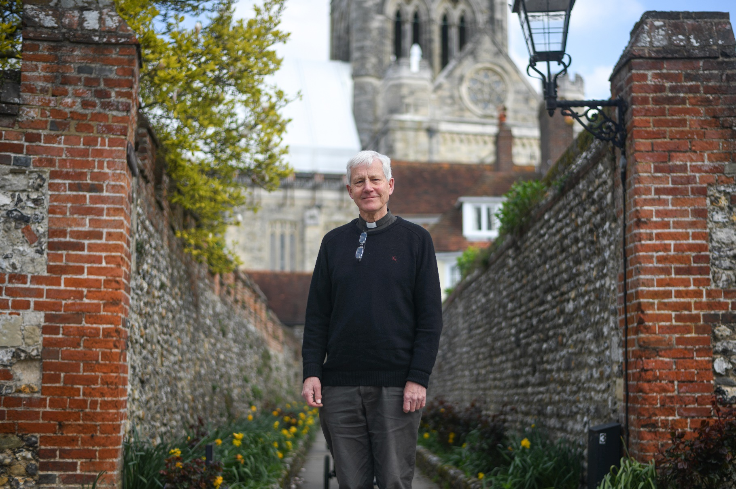

Welcome from the
Interim Dean of Chichester

Dear candidate

Thank you for your interest in the post of Verger at Chichester Cathedral.

The vergers are at the heart of the Cathedral’s life and their role is highly valued. Strong pastoral instincts and an eye for detail are essential qualities for the role, together with a sense of reverence and dignity.

The Cathedral is right at the heart of the city of Chichester and attracts many visitors and tourists. It has a rich liturgical tradition and a superb choir and hosts many cultural events. It has a strong congregation, including a growing number of families, and a close relationship with the Prebendal School, where the Choristers are educated. It also has a long history of engagement with the arts and supports a unique Workshop for Liturgical Art.

The Cathedral is at an exciting time in its history. Next year it will welcome a new Dean and in 2025 it will celebrate its 950th history. It’s a time for new beginnings.

The Reverend Canon Simon Holland
Interim Dean of Chichester
About Chichester Cathedral

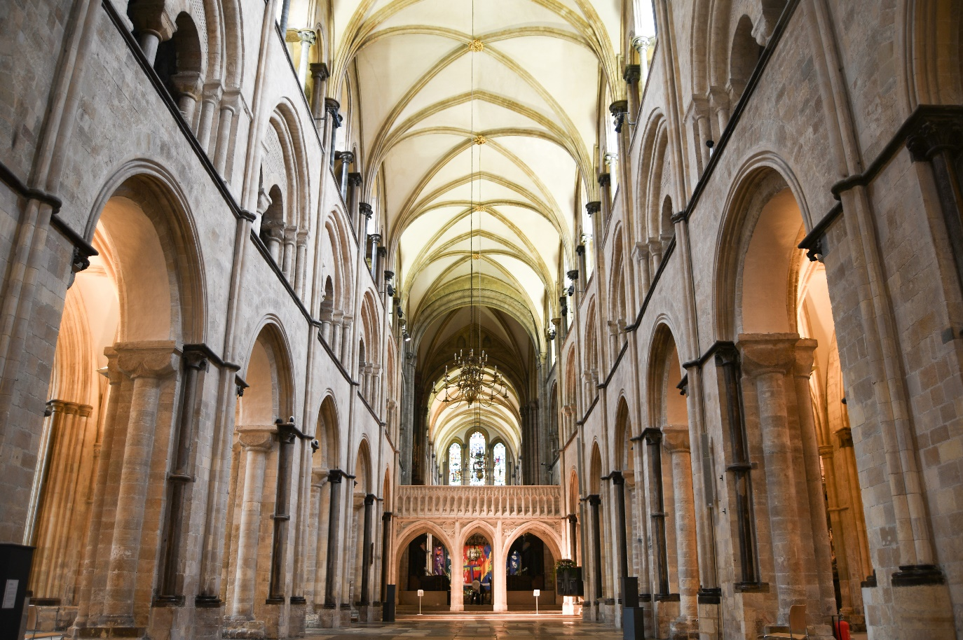
The Cathedral is a living church that has been at the centre of life in Chichester for over nine centuries. We are a place of worship and mission, the Mother Church of the Diocese of Chichester (which covers East and West Sussex) and the seat of the Bishop of Chichester. We are supported by a committed worshipping congregation, a small but dedicated staff team and over 400 volunteers.  The Cathedral is a leading visitor attraction, a venue for artistic and cultural activity, and an all-round hub for the community, welcoming over 250,000 visitors each year. Music is a central element in the Cathedral’s life. The Choir, which offers eight sung services each week and contributes to the Cathedral’s outreach around the diocese, has a high reputation at national and international level. We also host many high-quality musical performances each year by choirs, orchestras and chamber groups. | The Cathedral presents a comprehensive events programme and has a trading subsidiary, Chichester Cathedral Enterprises Ltd (CCEL), offering hospitality and retail services that support the Cathedral in delivering its mission. We have both a residential and commercial property portfolio many of them listed, in the Cathedral Close and beyond.  The Cathedral does not receive statutory or Church of England funding and is self-supporting, relying on self-generated income, donations, and fundraising activities. The Chapter is supported by the Chichester Cathedral Restoration & Development Trust and the Friends of Chichester Cathedral.  Further information about Chichester Cathedral can be found on the Cathedral website, including our Annual Report & Accounts.

Our Vision
The Cathedral’s anniversary in 2025 invited us to think more deeply about our purpose here in Chichester – in our worship, in our teaching, in our common life, in our commitment to diversity and inclusion and in our mission.
Invoking the prayers of St Richard, we have been drawn to that vein of spiritual renewal that animated the Latin West and especially this diocese in the thirteenth century – that is, the spirituality of St Dominic, which formed Richard and which shaped his own ministry here in Sussex, not least in resourcing his own pastoral care, teaching ministry, and expansion of the Cathedral’s life.
We’ve therefore taken inspiration from Dominican life in the so-called ‘Four Pillars’: Prayer, Study, Community and Mission. In these we begin to see a pattern of common life that helps us to fix our eyes on Christ as a means to becoming more prayerful; wiser in our understanding of what it means to be Christlike in the 2020s; becoming a community that is compassionate and joyful; and becoming more courageous in our mission and service to the world.
We hope you find inspiration and challenge in this pattern of life that we are setting before the Cathedral community and ask for your prayers as we seek to build up the household of faith here.

Prayer  Committing ourselves to seeking the face of God afresh in contemplation and worship, we hope to be guided by The Spirit to enter more deeply into the mystery of Jesus Christ and to radiate His beauty. | Study  Rooted in prayer, we seek to discern what it means to be human in an age of technological, political, social and economic change – through study, teaching and engagement with the World.
Community  Shaped by the insights of prayer, contemplation and study, we seek to build up our community in love, compassion and hospitality – encouraging each other to step out in faith and hope. | Mission  As a discerning, prayerful and loving community, we seek to take the message of God’s grace into the World with imagination, beauty and confidence, radiant with the promise of salvation.

You can read our full Vision document on the Cathedral website.

Commitment to Safeguarding
In accordance with Church of England’s policy, Promoting a Safer Church and the House of Bishops’ Safeguarding Policy and Practice Guidance, Chichester Cathedral is committed to the safeguarding of children, young people, and vulnerable adults who may be at risk.
The Cathedral works in partnership with the Diocese of Chichester to ensure that we operate in accordance with best practice at all times.
The care and protection of children, young people and vulnerable adults are the responsibility of the whole Cathedral community, whether clergy, staff, volunteers, contractors or members of the congregations. Everyone who participates in the life of the Cathedral has a role to play in promoting a safe environment for all.
To learn more about Safeguarding at the Cathedral please see our website.

Commitment to Equality & Diversity
At Chichester Cathedral we are dedicated to encouraging a supportive and inclusive workplace culture amongst our employee and volunteer workforce. It is our aim to ensure that if you work here or apply to work here, on either a paid or voluntary basis you will have an equal opportunity. We are also committed to working towards an organisation workforce that is diverse and as representative of our wider community as it can be.
We respect and value each of our employees and volunteers and are committed to enabling you to be able to perform to the best of your abilities and to be your authentic self in the workplace.

Job Description

Job Title: | Verger
Team: | Vergers/Operations
Location: | Chichester Cathedral
Line Manager; | Head Verger
Contract type: | Permanent
Hours: | Full Time  40 hours per week over on a 5-day rota which will include evenings and weekends.  NB The Cathedral is usually open between 7.30am and 6.30pm and the vergers’ team is responsible for its opening and closing.
Date of completion: | April 2024

1 | Job Purpose
 | Vergers are lay members of the cathedral staff who serve the church in a ministry of service and welcome. As a member of the Verging team, you have responsibility for the presentation, the security, and the maintenance of the building. You will undertake a leadership role in ensuring that the Cathedral is always presented in the absolute best way for worshippers, visitors, and the community.
2 | Principal Accountabilities
To ensure that the various activities that take place within the Cathedral are run smoothly including:
- being a welcoming presence for our worshippers, volunteers, visitors, and staff;
- being vigilant in relation to Cathedral health & safety and security, ensuring that all areas accessible to the public are maintained in a safe and secure manner and that any hazards or defects are reported to the maintenance team, so that it remains a safe environment in which to worship, visit and work;
- ensuring that services are set up correctly and as required so that the dignity of worship is upheld, and services run to time. This includes helping the member of the clergy responsible for conducting the service and participating in Cathedral services, as appropriate, under the direction of the Head Verger and/or the Precentor;
- working with Clergy and Day Chaplains, being the first point of contact for visitors in need of pastoral support or those in distress;
- providing support for regular events that are run in the Cathedral including rearranging furniture, operating the sound system and live streaming so that events can be well run for the benefit of worshippers and visitors;
- ensuring that the Cathedral is kept neat and tidy, including cleaning, removing rubbish etc, so that it is welcoming for worshippers and visitors;
- ensuring the safety and security of the buildings and its contents at all times including being a regular key holder for call-outs for which there is additional remuneration;
- undertaking any routine work as directed by the Head Verger and/or Senior Verger so that the Cathedral can operate effectively.

3 | Level of Responsibility
a | People  The post holder acts as a duty manager on the Cathedral floor and at different times has responsibility for Visitor Experience Staff, volunteers, and contractors.
b | Financial Management  The post holder does not have any direct financial responsibility but will be required to be familiar with the Cathedral procedures for handling cash.
4 | Contacts
The post holder will have contact with:
- members of the clergy to ensure the efficient running of services;
- members of the public, whatever their role, who visit the Cathedral to ensure their safety and security;
- colleagues in other departments to share internal communications and provide support as appropriate;
- contractors who work at the Cathedral to ensure that they can work effectively and safely.

5 | Special Requirements
The post-holder will:
- be a practising Christian and communicant member in the Church of England or other denomination in sympathy with the Anglican church;
- be required to have a satisfactory enhanced Disclosure Barring Services check;
- be required to undertake regular evening and weekend working and to have a flexible approach to working hours at busy times;
- be required to successfully complete mandatory safeguarding training;
- be required to act as an on-call key holder for the Cathedral and on occasion, Chichester Cathedral Enterprises for which there is additional remuneration.

6 | Qualifications, Skills, and Experience
Qualifications
- no formal qualifications are required but a general standard of education to GCSE or equivalent;
- Health & Safety training [fire safety, evacuation procedures, bomb safety, working at height] will be provided;
- Emergency First Aid at Work Certificate, training will be provided;
- Church of England Foundation Safeguarding Certificate [C1] - training will be provided.

Experience
Previous experience as a Verger, churchwarden or server is desirable.

Skills
- Confidence and leadership: you will need a calm authority with the ability to take charge is challenging situations;
- Resilience: physically fit as the role is physically demanding and involves lots of standing, manual handling activities and the movement of furniture and other heavy objects.
- Teamwork: ability to work effectively as part of a team, supporting colleagues and asking for support when necessary;
- Excellent communications skills: the ability to put people at ease and to communicate assertively to a wide range of people in an appropriate manner;
- Willingness to lean: an aptitude to understand and use technology including lighting and alarm systems as well as digital services;
- Excellent attention to detail and problem solving; a Verger has a full and active role in the liturgical life of the Church, and it can be exceedingly varied. This role requires a keen eye for detail and the ability to respond quickly to the needs of the Clergy, congregation, and visitors.

How to apply

You are required to complete an application form, available on our website: here

Please email your completed application to: Val Timlin, our Head of HR at:
HR@chichestercathedral.org.uk

- The closing date for applications is midnight on Sunday 19 May 2024.
- Interviews will take place in Chichester on Wednesday 29 May 2024.

If you wish to have a discussion about this role with Tim Morris, the Head Verger, please email him at: headverger@chichestercathedral.org.uk

Any questions?
Head of HR, Val Timlin
val.timlin@chichestercathedral.org.uk

